CanNor (for NBRF Grant & Contribution payments only)
DIRECT DEPOSIT REQUEST EXTERNAL APPLICANTS

Privacy Statement
The collection, use and disclosure of your personal information is required for your participation in the Direct Deposit Initiative and authorized by program specific legislation. We will collect, use, disclose and protect your personal information in accordance with the Privacy Act for payment purposes and uses judged to be consistent with that purpose. In some cases, information may be disclosed without your consent pursuant to subsection 8(2) of the Privacy Act. Should you decide not to provide the personal information requested, we will not be able to provide you with the service, program or funding requested. The personal information collected under this initiative is referenced in Personal Information Bank PSU 931. You have the right to access personal information that we hold about you and to request correction of erroneous personal information about you. Should you wish to do so, please write to the Coordinator of Access to Information and Privacy at the following address: Access to Information and Privacy, 90 Sparks St. 3rd floor, Ottawa, ON K1A 0H4. You may also write by email at cannor.atip-aiprp.cannor@canada.ca. To inquire about applicable legislative authority or to withdraw participation from this program, please contact your Regional Office or Public Enquiries at 1-855-897-2667. If you require clarification about this Privacy Act Statement, please contact our Access to Information and Privacy Office at 1-855-897-2667. Please note that you have a right to file a complaint to the Office of the Privacy Commissioner of Canada regarding our handling of your personal information. To do so, please contact the Privacy Commissioner at 1-800-282-1376.

New Change * Cancellation

1. Registered Name on the Account (Maximum 44 characters)

2a. Business No. (Federal)

3. Street Address, Apartment Number, Rural Route or Postal Box

4. City/Town | 5. Province/Territory | 6. Postal Code
7. Contact Person | 8. Title
9. Email Address (for payment notification) |  | 10. Telephone Number
Banking information is applicable ONLY to this business address.

Banking information is applicable to OTHER business addresses, extra page is included.

I certify that the above information is accurate and complete and that I have signing authority for the provided account.
I authorize the Receiver General for Canada to deposit the payment(s) directly into the provided account until further notice.

Applicant

Signature
Date (YYYYMMDD)
X
Government of Canada - Regional Contact

IMPORTANT

Please attach a VOIDED cheque or an attestation from the bank with your request form.
Return the completed form to your CanNor regional office using a secure method of transmission.
.
An amount of $2.01 may be deposited in your account in order to confirm the banking information.
Please confirm the reception of the deposit at the following addresses: cannor.finance.cannor@canada.ca; and aadnc.depotdirect-directdeposit.aandc@canada.ca.

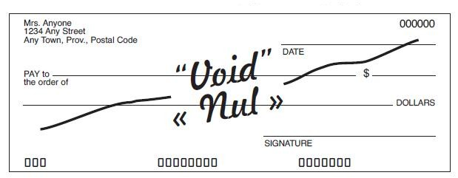
Corporate Accounting Use Only
Vendor Number
Date (YYYYMMDD)
By Name
Received in Corporate Accounting
Entered in Standard Payment System (SPS)
40CIRNAC
46CIRNAC
78CANNOR
40 ISC
47 ISC
Entered in SAP
Approved in Standard Payment System (SPS)
40CIRNAC
46CIRNAC
78CANNOR
40 ISC
47 ISC
Test Initiated

Test confirmed by Vendor
Confirmed in Standard Payment System (SPS)
40CIRNAC
46CIRNAC
78CANNOR
40 ISC
47 ISC
Enable in SAP

